1.8 I can store and retrieve files effectively, In line with local guidelines and conventions where available

During my course I have been required to complete a number of assignments and save them to my desktop. I have saved each individual file into folders as below depending on the Unit of work and the status of the assignment e.g. draft, final, to do etc.;

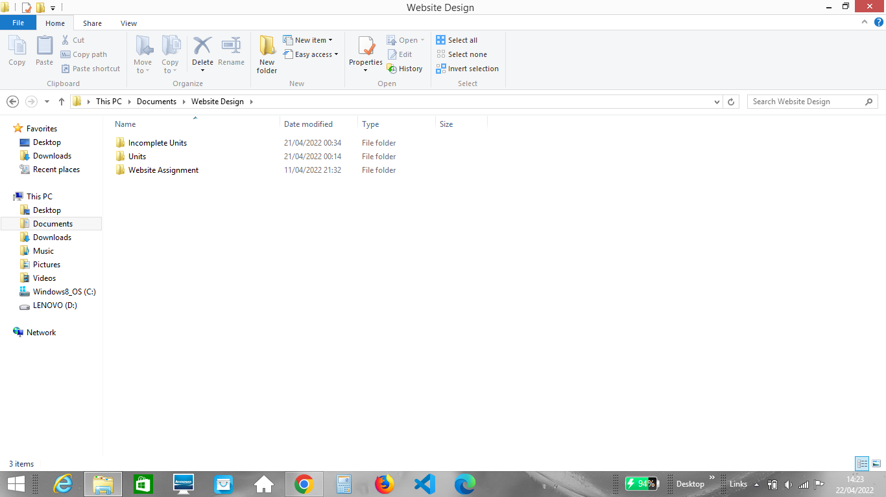

When creating my website using Visual Studio Code, I created a file with all the elements needed for my website, including images, a CSS file and a HTML file as below;

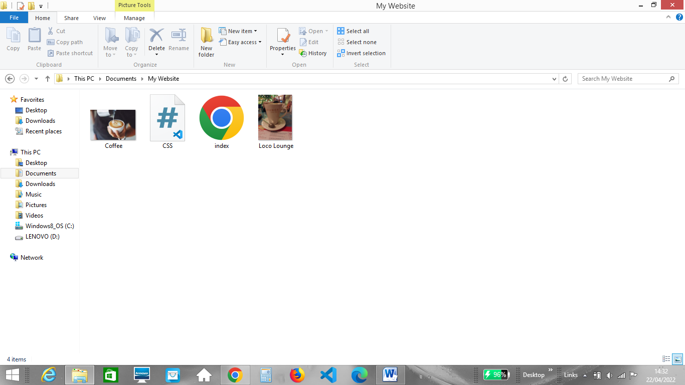

Within the HTML of my website I needed to link back to this folder for my CSS to work. Below is an image showing the link I created to refer back to the CSS file;

